

Plan of approach



Project:   
Baby Patient Simulator  
Students:   
Antonios Gkougkoulidis (654952)  
Youri Lucker (..)  
Mylo Speijers (640679)  
Marc Sutjipto (2101720)  
Niels Urgert (654746)  
Sima Zuri (565545)

Table of contents

Table of contents 2

Background 3

Project assignment 4

Problem definition 5

Current prototype problems 5

Planning 6

Quality and Risk control 7

Project goals 8

# Background

We are 6 students who work on the Baby Patient Simulator project in cooperation with the AEA Health Concept Lab, and HAN Research group on Resuscitation Feedback. We are really enthusiastic that we are a part of this project, so that we can help develop the best prototype baby patient simulator for the nursing schools. The project owner, Johan Korten, started in 2016 with designing a Baby Patient Simulator for teaching infant resuscitation for HAN Nursing school. Multiple project groups and student researchers have been helping with develop new prototypes since. Research has been done on wireless charging, power supply, skin, measurement of compression and ventilation, feedback through light and sound. The focus of our project group is the improvement and further development of the Ventilation and Compression system of the Baby Patient Simulator. The group comprises of 3 Embedded System Engineering (ESE) students and 3 Industrial Design Engineering (IDE) students. We will receive feedback and assistance if needed from 2 tutors, Peter Bijl who is an ESE teacher, and Matthijs Kwak who is an IDE teacher.

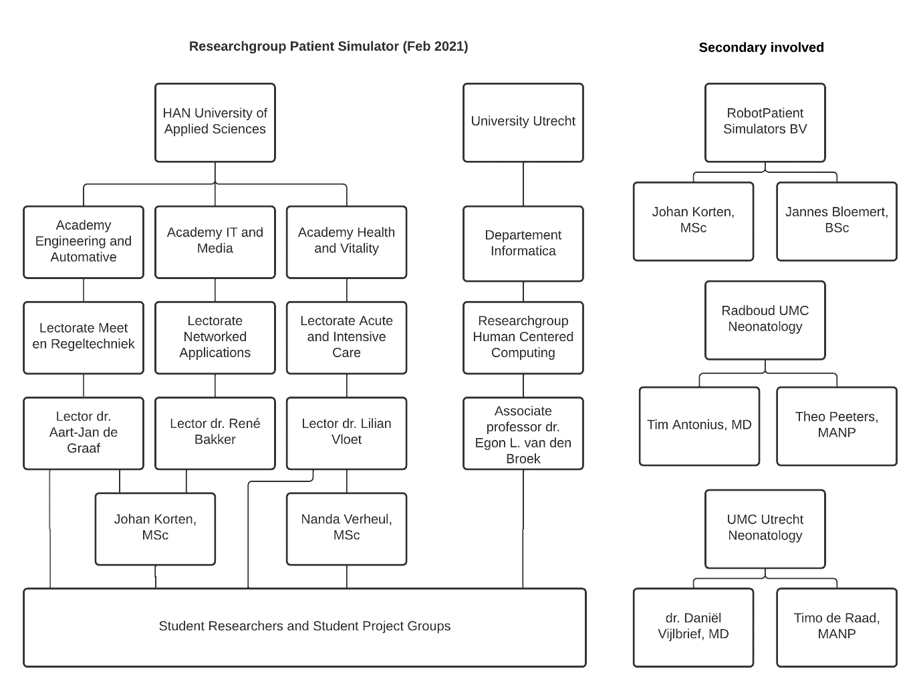

Figure 1 Organigram of the organisation

# Project assignment

Together with AEA Health Concept Lab, the HAN Research group on Resuscitation Feedback is working on a baby simulator. The simulator will be used for academic research on how we can improve automated real-time feedback for nurses at HAN Nursing school, Utrecht University, and Radboud University Children’s Hospitals.

The learning goal of this project is to research through building, testing, failing, learning, involving, and collaborating.

# Problem definition

A baby patient simulator for basic life support that can improve automated real-time feedback for teaching nurses. The problem with cheap manikins is that they aren't realistic and don't give feedback to the person giving CPR. The more realistic simulators are very expensive and not useful for large-scale education due to the high price. The challenge is to create an affordable modular real-time feedback simulator for basic life support. A prototype has been worked on in recent years. The current design has several limitations.

**The ventilation measuring system:**

There has been research for measuring ventilation with differential pressure sensors and airflow sensors. The current protype have a differential pressure sensor. The problem with the sensor is that moisture can accumulate in it, so the sensor becomes unreliable and can eventually break down. Airflow sensors are easy to clean, but the length and thickness of the tubes affect the measurement. Further research on ventilation measuring system is needed to solve the following problems:

1. The system isn’t accurate, and it is a problem that you cannot measure the volume of air going in or out. The users could get the wrong feedback during training and therefore they would be taught the wrong techniques.

2. The system (sensors) cannot be cleaned which may result in the unwanted growth of bacteria and the system can break down.

3. The system is quite big, and a more compact system is better, due to the limited space inside of the manikin.

**The compression measuring system:**

Hall effect sensor was used to measure depth. There is a recommendation to use ToF sensor. However, the ToF sensor has yet to be integrated to solve the following problems:

1. The compression system is not accurate. The users could get wrong feedback during their training and therefore they would be taught the wrong techniques.

2. Integration of new components needs to take place.

**Artificial lungs and airway:**

1. The lungs and airway are not realistic.

2. The materials for the lungs that are used are not re-usable.

3. Airway isn’t designed for new components (ribs, sensors e.g.)

4. Airway doesn’t block when performing the Head-tilt technique wrong

**Body**

A 3D design of the inner body was created and printed. This design can be continued to integrate with new parts. So the issue is:

1. Inner body isn’t designed with attachment points for new components.

**Thorax**

The original manikin had a spring. The spring has been replaced by foam to make it feel more real. However, that is not entirely realistic either. Previous group has research on 3D printing of the Thorax. Full 3D printed Thorax is not quite how it should be. So, we are left with a few problems:

1. The thorax isn’t realistic. The thorax doesn’t feel life-like when compressing

2. They are not giving the correct feedback.

# Planning

Current planning:

|  |  |  |  |
| --- | --- | --- | --- |
| **Week** | **Phase** | **To do** | **Goals** |
| **First period** |  |  |  |
| 1 | **Analyze** | * Make planning * Research | Answer the questions for yourself |
| 2 | **Define** | * Research * Problem definition * Analyze the problem | Plan of approach |
| 3 |  | Finish plan of approach!  Make a list of questions for Nanda Verheul  Contact  - Nanda Verheul (Nijmegen) - Lieke (Material) - David (S6) Critical useage scenarios | Make Requirement list |
| 4 | **Ideate** | Ideas, Concepts, and Design  (Based on the given feedback) Go over the requirements-list again and remove mistakes |  |
| 5 |  |  |  |
| 6 |  | Pre-Prototype |  |
| 7 |  |  |  |
| 8 | **Prototype** |  |  |
| 9 |  |  |  |
| 10 |  |  |  |
| **Second period** |  |  |  |
| 11 |  |  |  |
| 12 | **Test** |  |  |
| 13 | Paper/codes |  |  |
| 14 |  |  |  |
| 15 |  |  |  |
| 16 |  |  |  |
| 17 |  |  |  |
| 18 |  |  |  |
| 19 | Presentation |  | Deadline:  10th of June  - Project documentation (Report)  - Poster  - Videoclip |

# Quality and Risk control

|  |  |
| --- | --- |
| Risks | Explanation and action |
| **Intern** |  |
| Deadline | Due to a deadline, the assignments can be made or completed in a rush. That’s why there is a chance that the assignment will not be made properly.  This can be avoided by pushing the  deadline forward. This creates a buffer zone and is there enough time for defining the work. |
| Sickness and absenteeism | The absence of persons from the  project group can cause a backlog.  It can be remedied by a buffer zone in their own free time in which the backlog can be  caught up. |
| Not keeping promises | Not keeping promises with the group, will lead to having consequences. This will happen  by giving yellow and red cards. A  yellow card is a warning and a red card  means it is for the group member that the project is a knockout. |
| Unmotivated group members | Due to poor communication, an assignment can be made incorrectly. This  can be solved by creating a group app  to make agreements and for asking questions etc. Motivating your groupmate by cooperation will also help. |
| **Extern** |  |
| Dissatisfied client | While presenting the progress of the  project, the client may become dissatisfied.  It is therefore important to maintain good contact between you with the client. |
| The disappearance of files | Files may disappear due to a broken PC or not saving files. By saving the files in a  joint drive, like the teams environment, they will automatically become stored in the Cloud so they could never get lost. |

# Project goals

The main goal of this project is to have a working prototype that can be tested. Important to achieve this goal is the redesign of the ventilation and compression measuring systems so that they measure accurately and are reliable. Also, the prototype must become more realistic to look like an infant.

|  |  |
| --- | --- |
| **Analyze** | **Goal** |
| Target audience | Give the product features that are attractive for the users |
| Product | Create inspiration through existing variations and  provide insight into parts |
| Ventilation | Redesign design and measuring system |
| Compression | Redesign design and measuring system |
| Sensors | Give the user feedback about the use of the product. |
| Laws and regulations | Establish preconditions for the product |
| Stakeholders | Gain insight into the wishes of the parties product sale |
| Material | Provide information and opportunities for  applying materials in ideas. Make the design more realistic |
| Ideas |  |
| General sketches | Create ideas for the concept design |
| ESE… |  |
| Circular | Ideas for applicable circular parts  make on normal sketches |
| Graphic design | Visualize the created ideas for the client |